Exercise 1: Control Structures (MANDATORY)
create table customers (customerid number primary key, name varchar2(100), dob date, balance number, lastmodified date);

create table accounts (accountid number primary key, customerid number, accounttype varchar2(20), balance number, lastmodified date, foreign key (customerid) references customers(customerid));

create table transactions (transactionid number primary key, accountid number, transactiondate date, amount number, transactiontype varchar2(10), foreign key (accountid) references accounts(accountid));

create table loans (loanid number primary key, customerid number, loanamount number, interestrate number, startdate date, enddate date, foreign key (customerid) references customers(customerid));

create table employees (employeeid number primary key, name varchar2(100), position varchar2(50), salary number, department varchar2(50), hiredate date);

insert into customers values (1, 'John Doe', to_date('1985-05-15', 'yyyy-mm-dd'), 1000, sysdate);
insert into customers values (2, 'Jane Smith', to_date('1990-07-20', 'yyyy-mm-dd'), 1500, sysdate);

insert into accounts values (1, 1, 'Savings', 1000, sysdate);
insert into accounts values (2, 2, 'Checking', 1500, sysdate);

insert into transactions values (1, 1, sysdate, 200, 'Deposit');
insert into transactions values (2, 2, sysdate, 300, 'Withdrawal');

insert into loans values (1, 1, 5000, 8, sysdate, add_months(sysdate, 60));
insert into loans values (2, 2, 4000, 7, sysdate, add_months(sysdate, 60));

insert into employees values (1, 'Alice Johnson', 'Manager', 70000, 'HR', to_date('2015-06-15', 'yyyy-mm-dd'));
insert into employees values (2, 'Bob Brown', 'Developer', 60000, 'IT', to_date('2017-03-20', 'yyyy-mm-dd'));
commit;

begin
for rec in (select l.loanid, c.dob from customers c join loans l on c.customerid = l.customerid) loop
if floor(months_between(sysdate, rec.dob) / 12) > 60 then
update loans set interestrate = interestrate - 1 where loanid = rec.loanid;
end if;
end loop;
commit;
end;
/
begin
for rec in (select c.customerid from customers c join accounts a on c.customerid = a.customerid group by c.customerid having sum(a.balance) > 10000) loop

dbms_output.put_line('Customer ID ' || rec.customerid || ' is promoted to VIP.');
end loop;
end;
/

begin
for rec in (select l.loanid, c.name from loans l join customers c on l.customerid = c.customerid where l.enddate <= sysdate + 30) loop

dbms_output.put_line('Reminder: Loan ID ' || rec.loanid || ' for ' || rec.name || ' is due soon.');
end loop;
end;
/
select * from loans;

Output:
Customers Table:
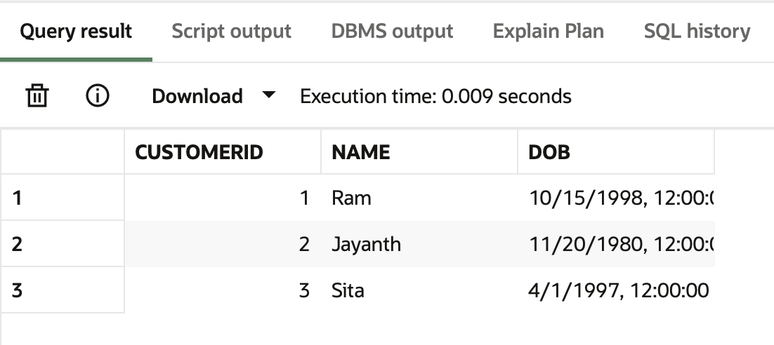
Loans Table:
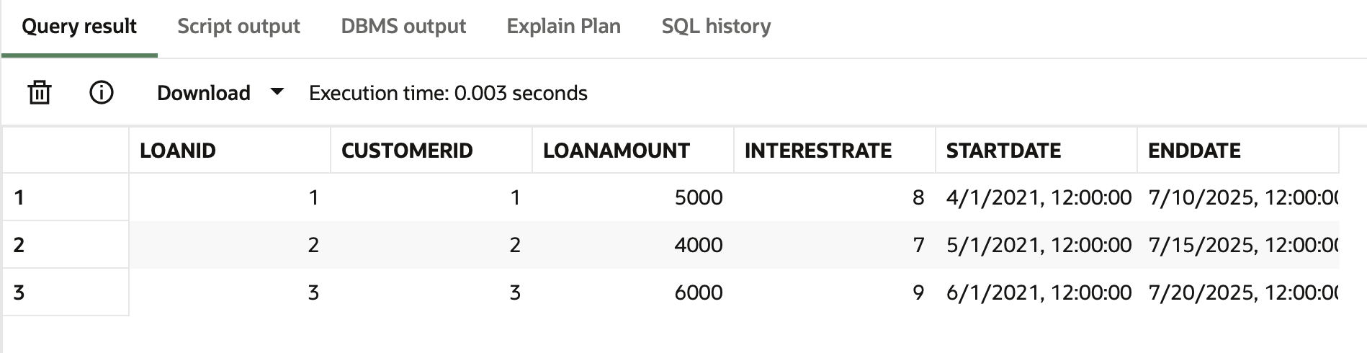

Output for our procedure:
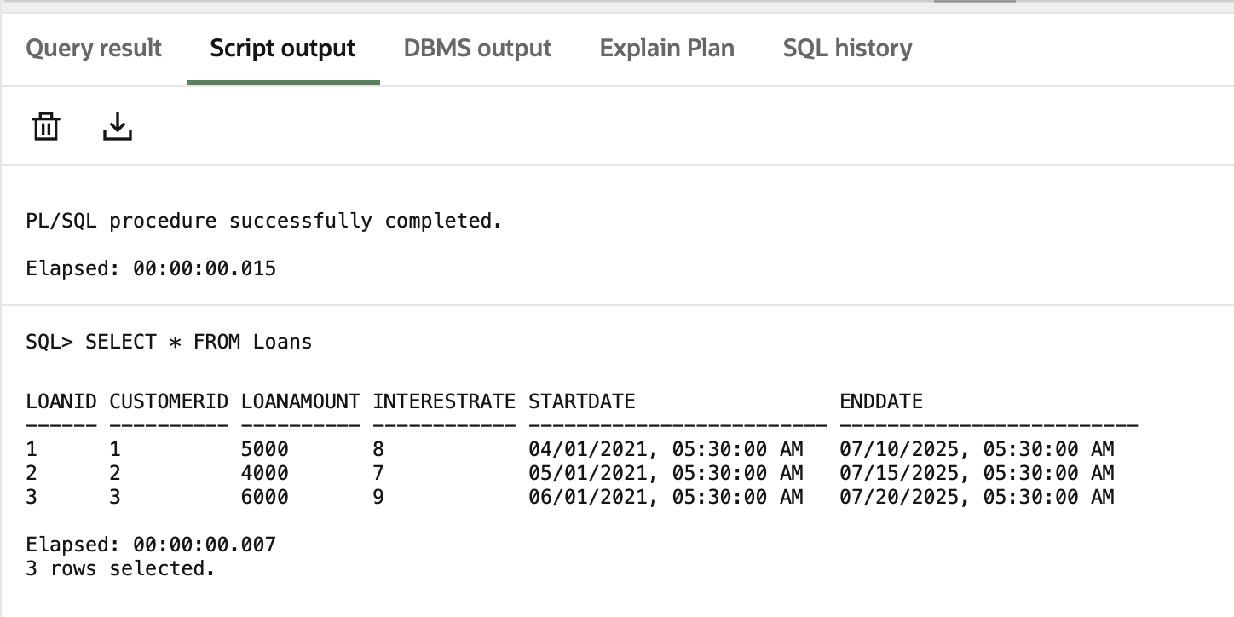

Exercise 3: Stored Procedures (MANDATORY)

create table customers (customerid number primary key, name varchar2(100), dob date, balance number, lastmodified date);

create table accounts (accountid number primary key, customerid number, accounttype varchar2(20), balance number, lastmodified date, foreign key (customerid) references customers(customerid));

create table employees (employeeid number primary key, name varchar2(100), position varchar2(50), salary number, department varchar2(50), hiredate date);

insert into customers values (1, 'John Doe', to_date('1985-05-15', 'yyyy-mm-dd'), 1000, sysdate);
insert into customers values (2, 'Jane Smith', to_date('1990-07-20', 'yyyy-mm-dd'), 1500, sysdate);

insert into accounts values (1, 1, 'Savings', 1000, sysdate);
insert into accounts values (2, 2, 'Savings', 1500, sysdate);

insert into employees values (1, 'Alice Johnson', 'Manager', 70000, 'HR', to_date('2015-06-15', 'yyyy-mm-dd'));
insert into employees values (2, 'Bob Brown', 'Developer', 60000, 'IT', to_date('2017-03-20', 'yyyy-mm-dd'));
commit;

create or replace procedure processmonthlyinterest is
begin
update accounts set balance = balance + (balance * 0.01), lastmodified = sysdate where accounttype = 'Savings';
commit;
dbms_output.put_line('Monthly interest processed for all savings accounts.');
exception when others then dbms_output.put_line('Error: ' || sqlerrm); rollback;
end;
/

create or replace procedure updateemployeebonus(dept in varchar2, bonus_percent in number) is
begin
update employees set salary = salary + (salary * bonus_percent / 100) where department = dept;
if sql%rowcount = 0 then dbms_output.put_line('No employees found in department ' || dept); rollback;
else commit; dbms_output.put_line('Bonus updated for department ' || dept); end if;
exception when others then dbms_output.put_line('Error: ' || sqlerrm); rollback;
end;
/

create or replace procedure transferfunds(from_acc in number, to_acc in number, amt in number) is from_balance number;
begin
select balance into from_balance from accounts where accountid = from_acc;
if from_balance < amt then dbms_output.put_line('Error: Insufficient balance.'); rollback;
else update accounts set balance = balance - amt, lastmodified = sysdate where accountid = from_acc;
update accounts set balance = balance + amt, lastmodified = sysdate where accountid = to_acc;
commit; dbms_output.put_line('Transfer successful.'); end if;
exception when no_data_found then dbms_output.put_line('Error: Invalid account ID.'); rollback;
when others then dbms_output.put_line('Error: ' || sqlerrm); rollback;
end;
/

begin processmonthlyinterest; end;
/

begin updateemployeebonus('IT', 5); updateemployeebonus('SALES', 10); end;
/

begin transferfunds(1, 2, 300); transferfunds(1, 2, 10000); end;
/

select * from accounts;
select * from employees;

Output:
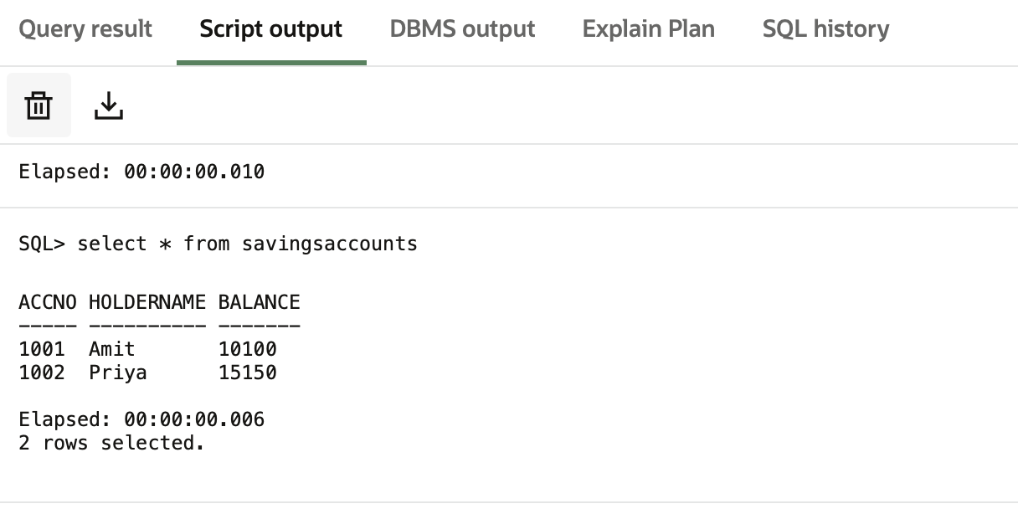
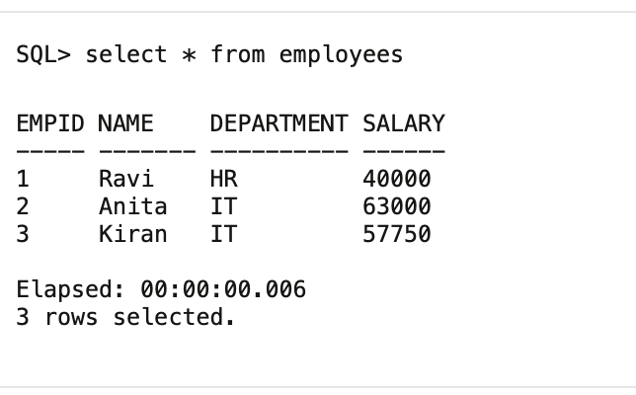
Final output:
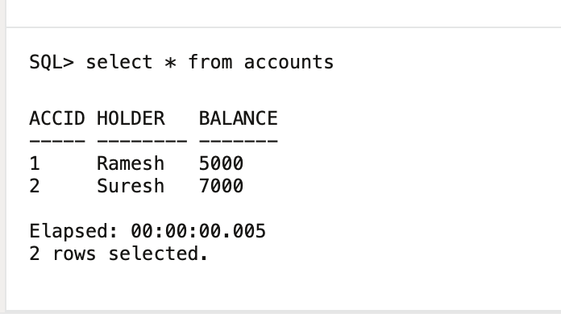
Implemented procedure

